GENERAL ORDERS

The two most important words in lifesaving are ANTICIPATION and COMMUNICATION
The Perimeter Defense System - Before making the rescue, the tower lifeguard contacts communications (Station 52) to let them know that he/she is going out on a rescue. The tower guard leaves phone off the hook. Communications will then contact the boat in the division where the rescue is happening, the lifeguard truck in that division and the two flanking lifeguard towers. The truck and the boat respond to the area and the flanking towers stand. The tower guards are responsible for watching their water, the rescuer’s water, and the rescue. Tower Zero also watches.
There are a total of 35 lifeguard towers on our beach; 10 odd numbered towers (1-19) in Division I south of the pier, 14 towers (2-28) in Division II north of the pier, 6 Towers in Division 3 (Sunset 4, 8, 12, 17, 22, 26), 4 towers in the harbors ( Davenport, Humbolt, Trinidad, and Seabridge ) and Tower Zero located on the pier.
Our Rescue vessels are named ‘The Sentinel’.
Making Rescues and Preventative Actions- Major Hazard ( MH ) + Potential Victim ( PV ) = Rescue or Preventative action. MV+PV=Rescue
Preventative Action- responding to a person or persons in order to advise them of hazardous conditions in order to keep them from becoming a rescue. A person who needs to be rescued is at greater risk for injury or loss of life.
Rescue- Physically assisting a person to shore
Mass Rescue- Physically assisting many people to shore. Often requires multiple lifeguards.
Signs of a Possible Beach Patron in need of Assistance
Victims swimming with hair in their face
People swimming in jeans, shirts, sweatshirts, or other heavy clothing
Small children near inshore holes who are unsupervised
People jumping/falling off their body boards or other surf equipment
People with poor swimming strokes
People swimming against a rip current or the side current
Individuals swimming with head low in the water
Steps to making a rescue
Path to Victim | High Step Dolphin, out fast | Swim W/head up | Stop Before victim | Victim Check | Contact W/in surf  (Through  Pier ) | Victim to dry shore | Buoy Control (overall) | Buoy Wrap

Tower Zero
Lifeguards are in Tower Zero 365 days per year from sunrise to sunset.
Three shifts in 0:
Zero A will open tower 0 in the AM
Zero B will work throughout the middle of the day
Zero C will close the tower in the evenings
Tower Zero functions as Communications in the Winter and outside of typical operation hours
Two phone lines: Line 1 for emergencies only and Line 2 for routine calls
Tower zero guard updates the Surf Report 3 times a day during summer and twice during the rest of the year. This includes Water temp, winds, and tides.
(714-536-9303)
Hazardous Beach Practices:
Any activity on the beach that the Marine Safety personnel deem to be a hazard to the general public on the beach. This tends to be crowd and conditions dependent. For example a large tackle football game, while not against the law, can lead to serious injuries and require a large number of lifeguard staff if there were significant injuries. Often tackle football games are deemed to be Hazardous beach practices. In the same vein playing a game using a baseball might be fine and acceptable on an uncrowded day, but if the Beach Crowds are large, a baseball could be very dangerous. Both of these activities could be deemed unsafe on a given day and be acceptable on another.

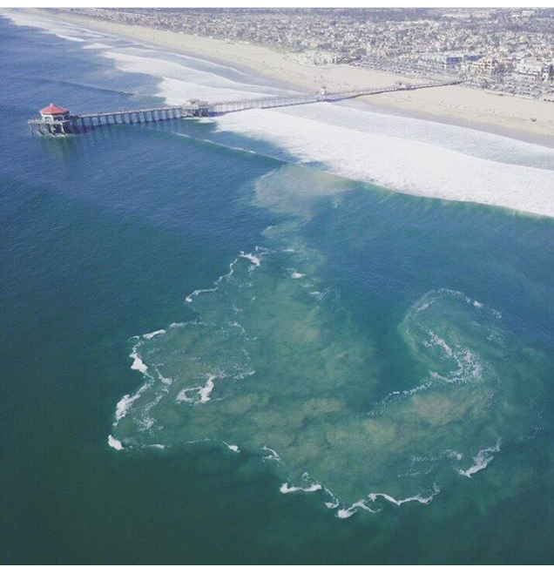
Law Enforcement: As a public service agency the Huntington Beach Marine Safety department is also tasked with helping to enforce the municipal codes that apply to the beach. In order to that we seek voluntary compliance. This means that we inform the beach patrons about laws of which they may be in violation. We ask them to change their behavior in order to be within regulation. If they are non-compliant we will have the police come to assist and/or cite individuals who have broken the law. Common occurrences of this are violations regarding dogs or alcohol on the beach, Jumping from the pier and riding bikes and skateboards on the pier.

Surf Hazards
Rip Currents- moving water returning to sea after being pushed onto shore by wave energy. Water will take the path of least resistance. This phenomenon will typically be near holes on sandy beaches. Will form next to fixed structures in ocean ( i.e. pier pilings, reef passages, jetties and groins, submerged rocks )
The feeder leads to the neck of the rip and the neck proceeds to the head. The neck is the strongest part of the rip current. Rip currents are the number one cause of rescues on our beach. To get out of a rip current, swim parallel to shore and then swim in.

How to Identify a Rip Current: Brown and choppy looking water, collection of detritus outside the surf in the head of the rip and waves not breaking cleanly or at all in the area, locating fixed objects or submerged objects in the area.
Large Surf- In HB large surf is typically “walled” or the wave breaks all at one time. The largest swells in HB and surrounding areas comes from very far across the ocean and has a long period. ( see waves lecture for terminology )
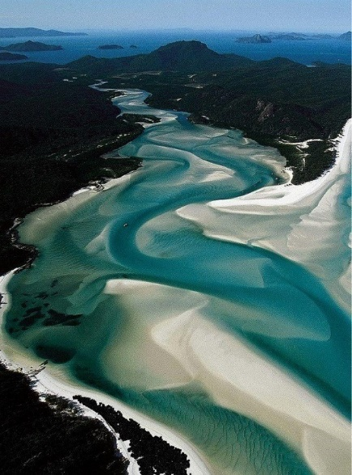
Side Currents or Longshore Current- Surf does not typically come directly into shore. The direction the current travels will be Dependent on where the swell originates. Swells from the South will cause a current that moves from HB state beach towards Bolsa Chica Beach. Swells from the North will cause a current that moves from Bolsa Chica beach towards HB state beach.
Inshore Holes- Deep areas in the ocean bottom. Next to Sand Bars.
Sand Bars- Shallow sandy areas in the ocean bottom. Next to Holes.
Pier- Large Concrete structure that extends over the ocean surface. Pilings are the “Legs” of the pier. “T”s are the portions of the pier that are a wider landing. There are four “T”s on the HB pier.
Sea Creatures –
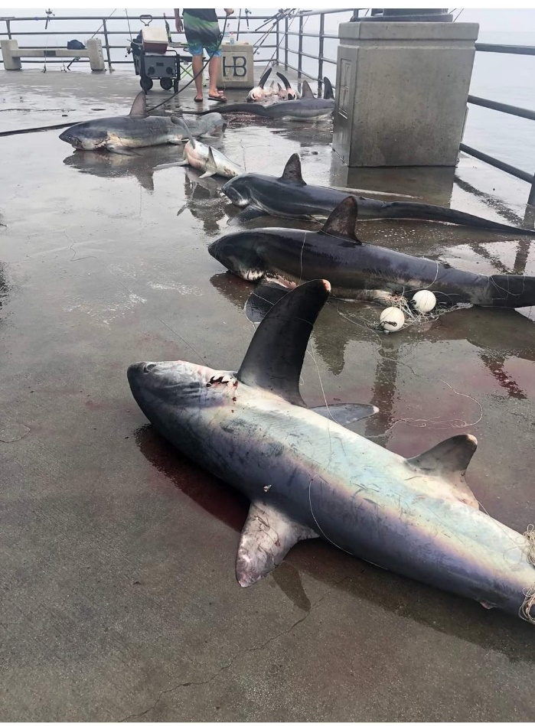
Jellyfish- Jellyfish are mainly free-swimming marine animals with umbrella-shaped bells and trailing stinging tentacles. Jellyfish in HB typically have a mild sting that can leave an itchy rash to raised welts. Some species that are endemic to different portions of the world can have very painful or even deadly stings
Stingray- Stingrays are a group of sea rays, which are cartilaginous fish related to sharks. Stingrays are not usually aggressive and ordinarily attack humans only when provoked, such as when a ray is accidentally stepped on.^{[34]} Contact with the stinger causes local trauma (from the cut itself), pain, swelling, muscle cramps from the venom, and later may result in infection from bacteria or fungi.
Muscles- is the common name used for members of several families of bivalve mollusks. In most marine mussels the shell is longer than it is wide, being wedge-shaped or asymmetrical. The external color of the shell is often dark blue, blackish, or brown, while the interior is silvery
Sharks- Sharks are a group of fish characterized by a cartilaginous skeleton, five to seven gill slits on the sides of the head, and pectoral fins that are not fused to the head. Common sharks seen in HB are juvenile White sharks and Thresher Sharks.
Dolphins and Porpoises- Dolphins are small-toothed Cetaceans, a group of marine mammals that evolved from land mammals. Dolphins have curved beaks which means they appear to have permanent smiles. Porpoises are marine mammals, similar in appearance to a dolphin. Porpoises are recognized from dolphins by their flattened, spade-shaped teeth distinct from the conical teeth of dolphins, and lack of a pronounced beak
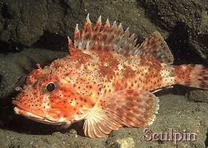
Whales- any of various very large, aquatic, marine mammals that have a torpedo-shaped body with a thick layer of blubber, paddle-shaped forelimbs but no hind limbs, a horizontally flattened tail, and nostrils that open externally at the top of the head. Grey Whales are common to Oceans off of Southern California as they migrate.
Rock Fish or Sculpin - Sculpins occur in many types of habitat, including ocean and freshwater zones. They live in rivers, submarine canyons, kelp forests, and shallow littoral habitat types, such as tide pools. Sculpin spines are poisonous and can cause a very painful reaction and anaphylaxis

